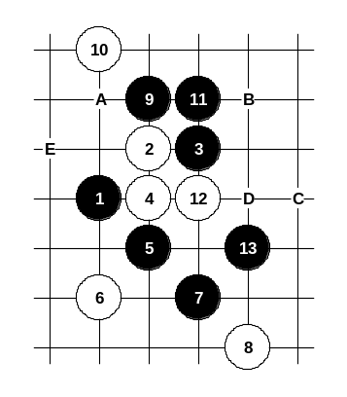
The first choice of the 6th move. It is very weak move and lets black create very strong attack. By the 13th move black already wins.

Diagram i2-40
If 12-A then 13-13. If 12-B then 13-C.
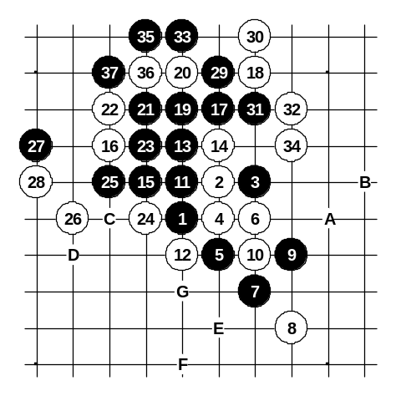
If 10-D then 11-A. If 10-11 then black begins straight attack with 11-10. If 8-E then black has straight win.

Diagram i2-41
Another 6th move.
It is too passive. With moves 7-7 and 9-9 black prepares the winning position. After the 14th move black wins with standard attacking pattern that ends at 37th move. If 14-19 then 15-A, 16-B, 17-15, 19-C, 20-D, 21-24.
If 12-13 then 13-E, 14-F, 15-G.
If 12-G then 13-19, 14-13, 15-14.
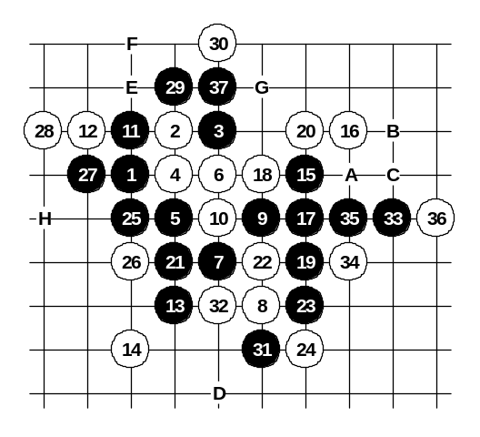

Diagram i2-42
Another 12th move. Black wins after key move 17-17. If 18-29 then 19-19, 20-20, 21-22, 22-21, 23-34, 25-18, 27-A, 28-B, 29-C, 31-D.
If 18-19 then 19-29, 20-18, 21-E, 22-F, 23-21 (if 20-F then 21-G). If 18-20 then 19-18, 20-29, 21-22. If 18-22 or 18-34 then 19-25, 20-26, 21-F, 23-29, 25-27, 26-H, 27-28.
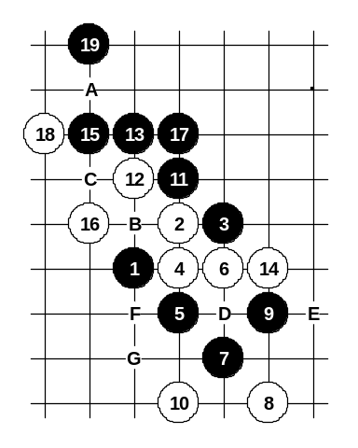

Diagram i2-43

Another 10th move.
Beautiful 11-11 connects the black sources.
If 16-A then 17-18.
If 12-B then 13-13, 14-14, 15-C.
If 12-13 then 13-D, 14-E, 15-F, 17-G.

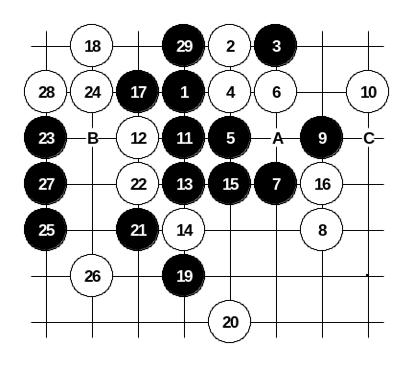

Diagram i2-44
Another 10th move. Black can begin immediate attack from move 11. Of course, there may be more ways to win, but I prepared the attack on this diagram in order to show the power of threat moves 19-19, 21-21, 23-23 and 25-25. All white’s defense moves are forced, that makes it easy to learn. If 12-A then 13-29, 14-13, 15-B. If 10-C then 11-12.
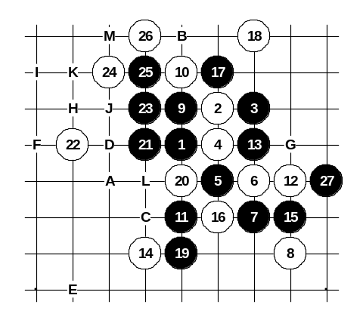

Diagram i2-45
Another 6th move.
Black win here is really difficult. Therefore, I publish here all the important continuations. It is very useful to memorize them all because in real game it might be too difficult to find the win without having knowledge about it. With move 11-11 black prepares the base for the attack. Move 17-17 – another important preparation move. Japanese theory tells about 19-21 but there after 20-19 black win is difficult or maybe even impossible. Moves 19-19 and 21-21 on this diagram give easy black win.
If 22-A then 23-23, 25-25, 26-26, 27-B, 29-22.
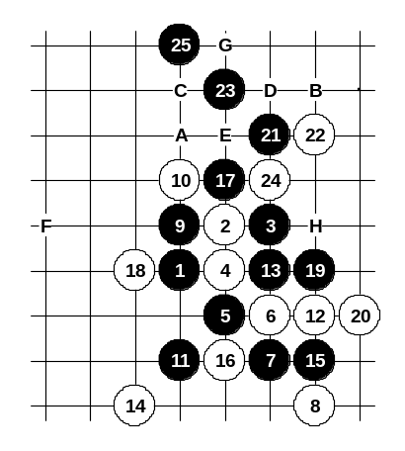
If 22-C then 23-24, 25-D, 26-E, 28-F, 29-G, 30-27, 31-H, 32-I, 33-J, 34-A, 35-K, (if 32-L then 33-A, 35-M, 37-K).

Diagram i2-46
Another 18th move. Black moves 19-19 and 21-21 prepare the attacking base. Any other 22nd move loses fast, too.
If 18-A then 19-19, 20-B, 21-C, 22-D, 23-E, 24-24, 25-F, (if 22-E then 23-D, 25-G).
If 14-H then 15-14, 17-16.
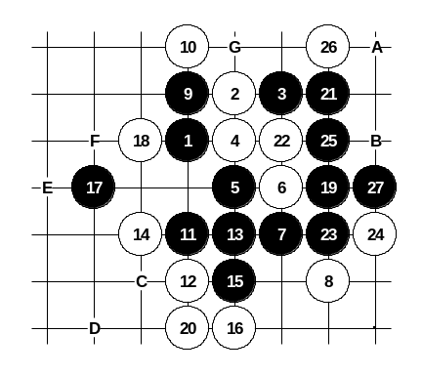

Diagram i2-47
Another 12th move. Black wins.
If 22-A then 23-23, 25-27. If 20-B then 21-C, 22-D, 23-E. If 18-F then black wins easily with 19-G.
In case of any other 18th move, black can either win immediately on the left side or develop similar attack as shown on the diagram.
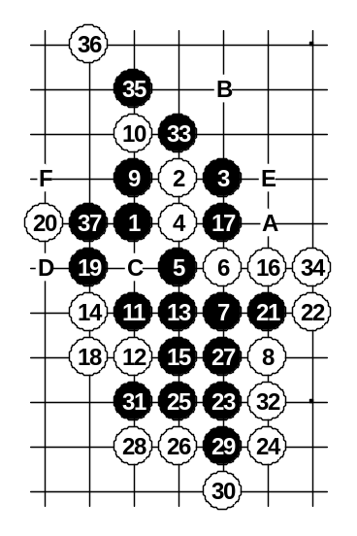

Diagram i2-48
Another 16th move. After 37th move black has VCF. If 34-A or 34-35 then 35-B and black has VCF. If 28-34 then 29-C. If 20-23 then 21-D. If 18-E then 19-21, 21-23 and black wins fast on the lower side.
If 16-21 then 17-19, 18-20, 19-18 (if 18-23 then 19-D).
If 16-17, 17-16, 18-31 then 19-37, 20-C, 21-33.
If 16-23 then 17-16, 18-31, 19-E, 20-17, 21-A.
If 16-31 then 17-37, 18-F, 19-33, 20-D, 21-25, 23-34.
If 16-19 then 17-16, 18-31, 19-21, 21-E, 22-17, 23-34 (if 22-18 then black has VCF).
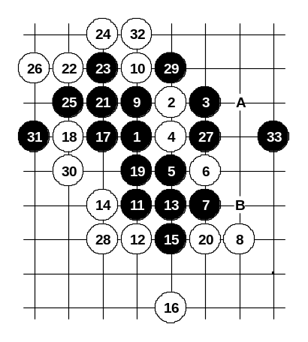
The last choice of the 16th move. Although black has lots of attacking material, it is not easy to find good move or right attacking sequence. Move 17-30 is winning move, too, but the win is too difficult after 18-17. Move 17-17 is the best solution – it leaves three white pairs open, but all those white pairs are under black’s control, and black wins. If 28-A then 29-30. If 18-30 then 19-31.

Diagram i2-49
If 14-B then 15-17.
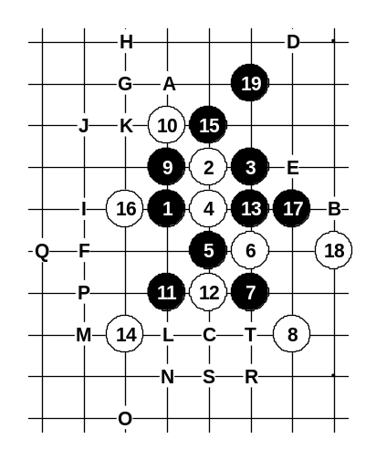

Diagram i2-50
Another 12th move. Black winning plan is quite simple here. If 18-A then 19-B.
If 16-19 then 17-17, 18-18, 19-C.
If 16-A then 17-19, 18-D, 19-B, 21-C.
If 16-E then 17-16, 18-F, 19-G, 20-H, 21-I, 22-J, 23-A, 24-19, 25-K.
If 16-17 then 17-L, 19-16, 20-F, 21-G.
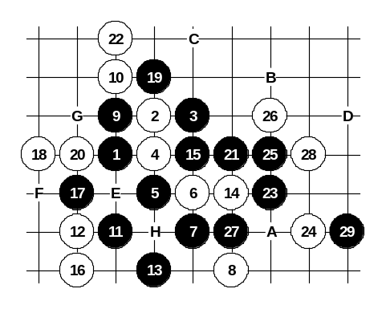
If 14-E then 15-14, 17-L, 19-C, 20-M, 21-N, 22-O, 23-P, 24-Q, 25-R, 27-S and VCF (if 20-T then 21-16).

Diagram i2-51
Another 12th move. Here the black win is difficult and requires very precise sequence of moves. Black wins with beautiful 29-29. If 26-A then 27-B, 29-C, 30-26, 31-D.
If 22-23 then 23-C.
If 20-C then 21-E, 23-F, 25-20, 27-G, 29-H.
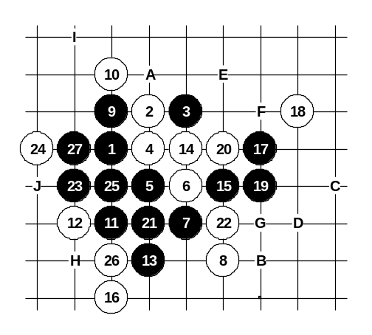

Diagram i2-52
Another 14th move. One renju opening book claims that after 14th move black has no sure winning attack. However, Mr. Tsai analysis proves black win here after 17-17 and 19-19. If 20-21 or 20-26 then 21-20, 22-A, 23-B, 25-C (if 22-D then 23-E, 25-F). If 20-F then 21-21. If 20-G then 21-A. If 14-26 then 15-21 (look at the diagrams i2-47 and i2-48). If 14-H then 15-27, 16-I, 17-14, and black wins. If 14-25 then 15-14, 16-H, 17-A, 18-23, 19-27, 20-J, 21-15.
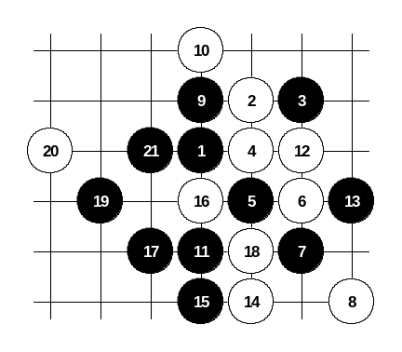

Diagram i2-53
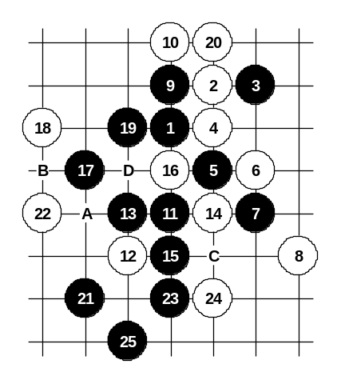
Another 12th move. All black wins are very simple here. The strongest 14th moves are of course 14-17 and 14-15, but both moves lead to the variants that have been discussed before on previous diagrams. If 14-17 then 15-14 and look at the diagram i2-52. If 14-15 then 15-14, 16-A, 17-18, 18-17 and further steps are shown in the comments of the diagram i2-48.

Diagram i2-54

Another 12th move. All stronger 12th moves have already been discussed above. This 12th move is very weak – black wins with straight attack.
If 12-16 then 13-13, 14-14, 15-19 (if 14-A then 15-19, 16-16, 17-17, 18-20, 19-15, 20-16, 21-18, 23-22, 25-B).
If 12-C or 12-D then 13-13, 14-14, 15-15, 16-16, 17-17.
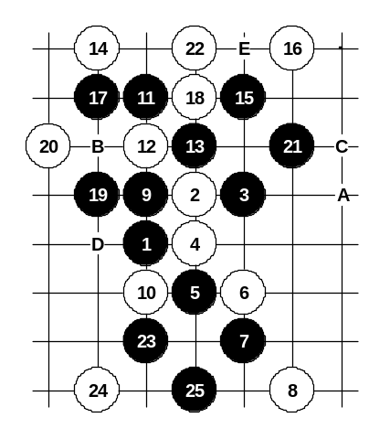

Diagram i2-55

Another 10th move. Move 11-11 prepares sure win position.
If 22-A then same 23-23 and 25-25.
If 22-B then 23-C.
If 16-D then black’s winning attack begins with 17-E.

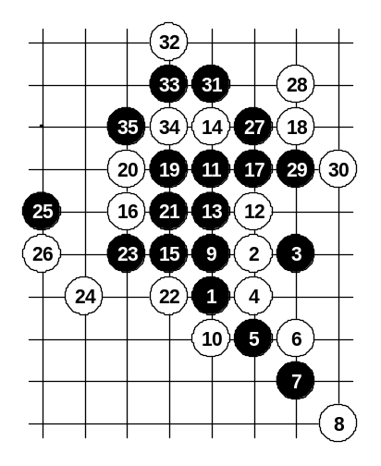

Diagram i2-56

Another 14th move.
Black wins with classical attacking pattern.

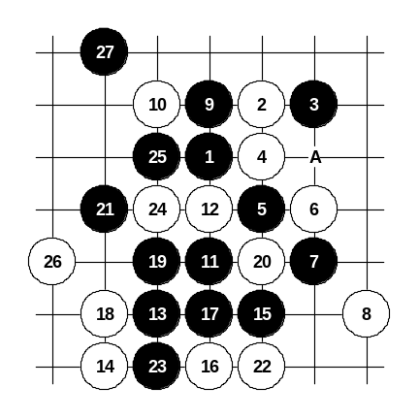

Diagram i2-57

Another 10th move. Moves 11-11, 13-13, 15-15 prepare the winning position. All the variants are very simple here. The variant on the diagram is the best white resistance, but still easy black win.
If 14-A then 15-19, 16-20, 17-23.
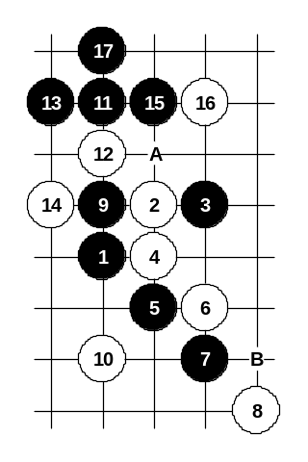

Diagram i2-58

Another 10th move. Straight attack with 13-A does not bring success, therefore black plays more carefully 13-13 and gets winning position by the 17th move.
If 8-14 then 9-8, 11-B.
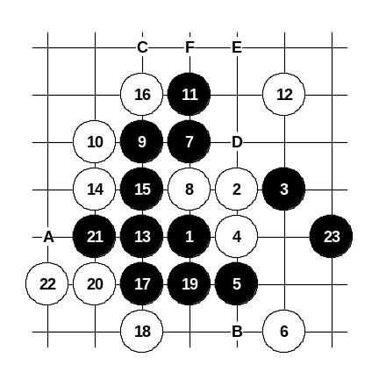

Diagram i2-59

Another 6th move. Simple 8-8 is perhaps the best resistance, but black wins anyway.
If 14-15 then 15-14, 16-A, 17-19, 18-B, 19-C, 20-D, 21-E, 23-F.
If 14-D or 14-E then 15-15.
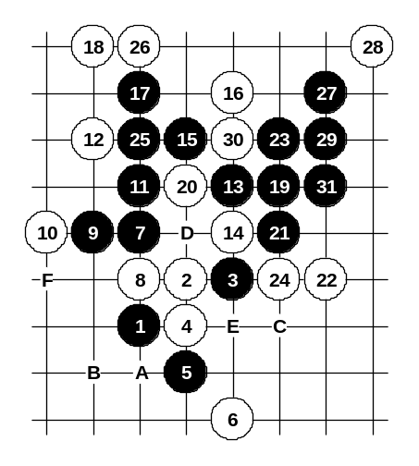

Diagram i2-60
Another 12th move. From move 15 black begins straight attack. It is also possible to win with beautiful connection 19-A, 20-B, 21-C(!) – with learning this style a player can understand more about the importance of key points and good connections.
If 14-15 then 15-14, 16-30 and black VCF.
If 12-F then black begins straight attack with 13-D.
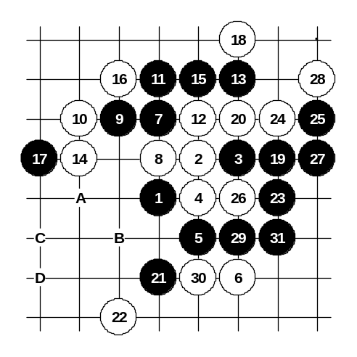

Diagram i2-61

Another 12th move. Move 14-14 is very aggressive and black has to defend for a moment. In move 19-19 black prepares winning attack.
If 22-26 then 23-A, 24-B, 25-C, 27-D.

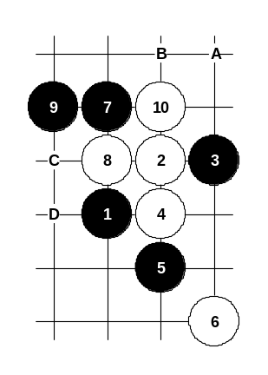

Diagram i2-62

Another 10th move.
White position is really weak and black has four good choices here: 11-A, 11-B, 11-C, or 11-D – all of them practically give black win. Everyone can choose and prepare his favorite 11th move here.
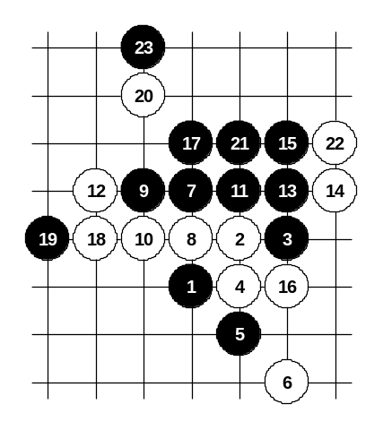

Diagram i2-63

Another 10th move.
Move 11-11 – good timing!
White has no time to set up defensive structures.
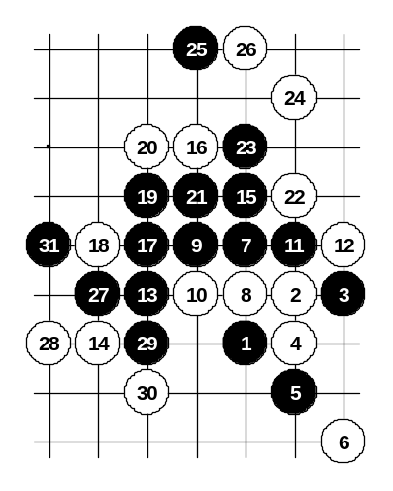

Diagram i2-64

Another 12th move. Move 13-B – the only way to the victory.
Move 14-14 is made in order to avoid black’s development towards left lower side. Black wins in classical style, similar to diagram i2-56.
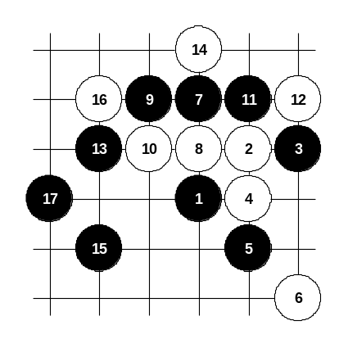

Diagram i2-65

This is how black wins if white lets black to develop towards the left lower side.

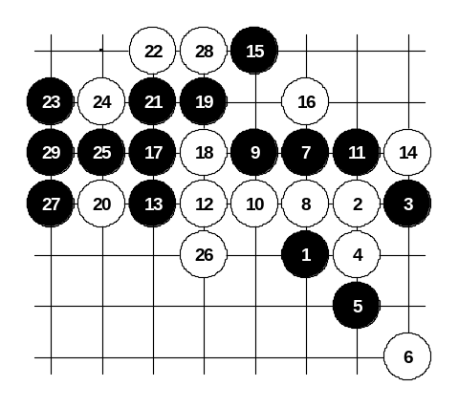

Diagram i2-66
White uses a four before blocking black’s three. Besides the variety of good positional moves, black can also win by straight attack as shown on the diagram. After 29th move black has VCF, no matter how white defends.
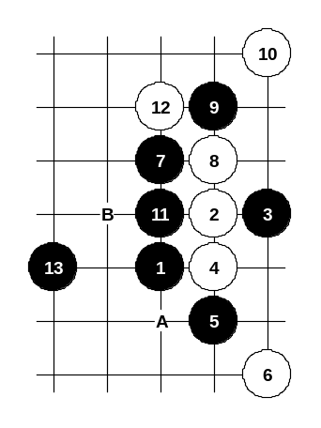

Diagram i2-67
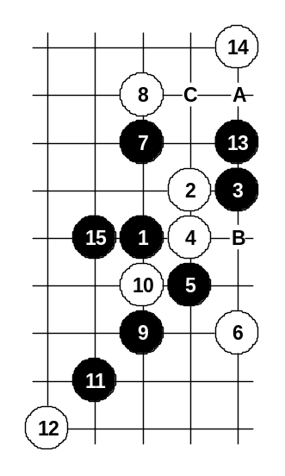
Another 8th move. By the 11th move the position is symmetrical. If 12-A then black’s win is similar, the board edge’s closeness does not influence black’s attack. If 10-B then black begins straight attack with 11-12.

Diagram i2-68

Another 8th move. Move 15-15 is a key point – it connects the left and right side. If 14-A then black has a straight win.
If 14-B then 15-C.
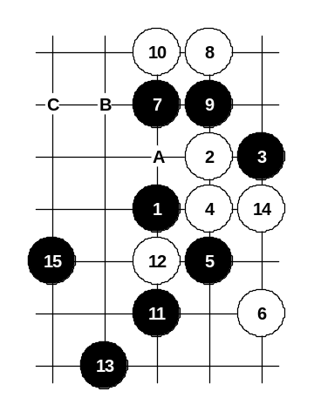

Diagram i2-69

Another 8th move.
Move 10-10 is forced.
If 10-A then 11-B, 12-C, 13-10.

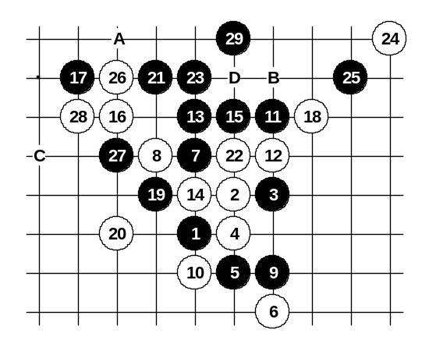

Diagram i2-70
Another 8th move. It is quite interesting. Move 9-9 is the best – it gives black winning attack. If 22-A then black wins exactly in the same way. If 20-B then 21-21, 22-any, 23-26, 24-23, 25-28, 27-C. Any other 14th move gives simple black win. If 12-13 then 13-12, 15-B, 17-D.
If 12-15 then 13-22 – an easy win.
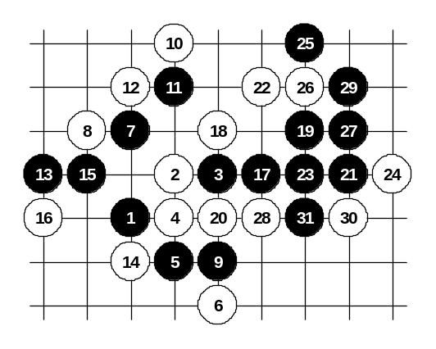

Diagram i2-71
Another 10th move – very beautiful and aggressive. It provokes black to play 11-12. However, black has to play calmly 11-11 and let white take the point 12. After 13-13 there is no defense. The variant on the diagram is the best resistance. If 26-31 then 27-28. If 20-29 then 21-28.

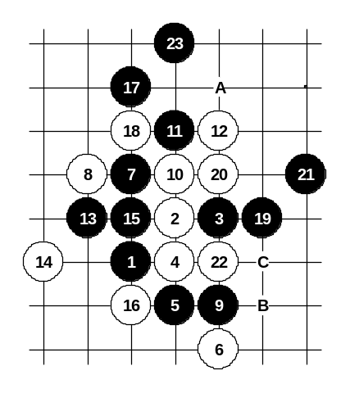

Diagram i2-72
Another 10th move. Black gets very powerful structures after 11-11 and can attack all over the board.
If 12-A then 13-19. If 12-13 then 13-B, 15-19.
If 10-11 then 11-10.
If 10-C then 11-20 and after any 12th move black wins with straight attack.

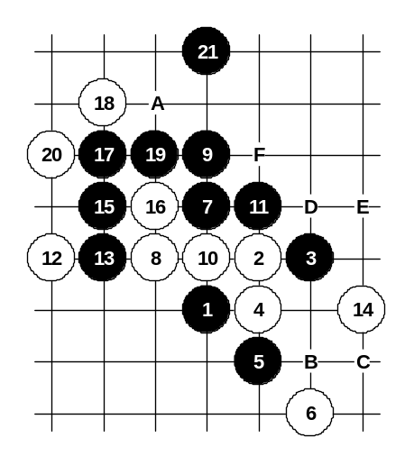

Diagram i2-73

Another 8th move. Black can win directly from move 9-9.
If 14-A then 15-B.
If 12-A then 13-B, 14-C, 15-D, 16-13, 18-E, 19-F.
If 12-14 then 13-16.

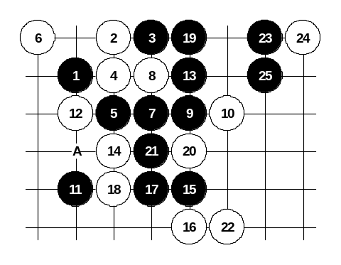

Diagram i2-74

Another 6th move.
Move 7-7 is very powerful and gives black straight attack in case of any 8th move.
If 12-A then 13-14 and black wins on the lower part of the board. If 18-21 then 19-12. If 8-10 then 9-13.
Move 7-21 is also possible but win there is not so easy.

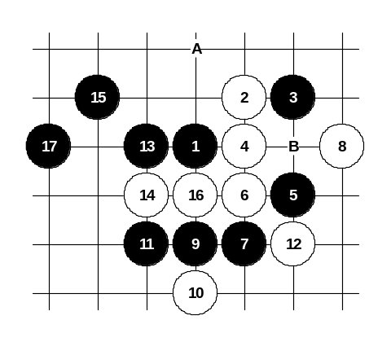

Diagram i2-75
This is the alternative 5th move.
It is important to notice that similar attack as on the diagram does not work in case of 5-A due to the board edge’s closeness. That is one of the reasons why the 5-5 is often used instead of 5-A.
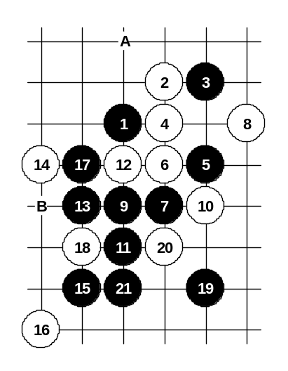
I remember, moves 15-15 and 17-17 were one of my first serious home analyses in the age of 15. I had begun to realize the importance of space development at that time. The old theory recommends 11-A or 11-B, 13-A, but there the black attack is more difficult.

Diagram i2-76

Another 10th move.
As I did not like the idea of 11-A, I searched for simpler win. Move 11-11 leads to quite simple win.
If 14-B then 15-17.
If 14-15 then 15-14.

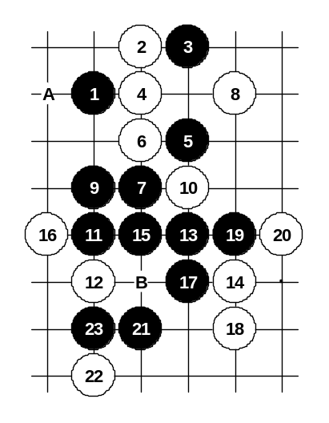

Diagram i2-77

Another 12th move.
Black wins easily here as well.
If 14-A then 15-15, 16-19, 17-B.

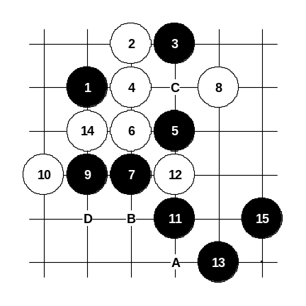

Another 10th move. As the points 10 and 11 are both good defense points for white, therefore black is forced to play immediately 11-11 which is very good move.

Diagram i2-78
If 12-A then 13-13, 15-15.
If 12-14 then black wins with straight attack beginning with 13-12, 15-A, 17-B. If 12-C then 13-D, 15-B.

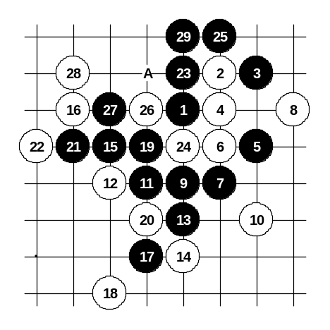

Diagram i2-79
Another 10th move.
It is quite strong. Black can win here after long series of careful moves.
If 22-24 then 23-27, 24-28, 25-A.
If 14-24 then 15-19.

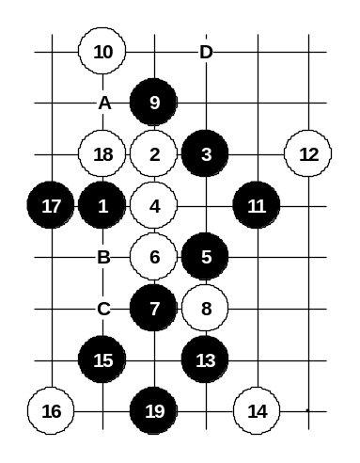

Diagram i2-80

Another 8th move.
In fact, all other 8th moves here are very weak and usually black has many different ways to win. Move 9-9 is a good example. It shows the power of diagonal connections.
If 10-A then 11-15, 12-11, 13-B, 14-C, 15-17.
If 10-11 then 11-A. If 8-9 and 10-8 then 11-D.
If 8-15 then look at the diagram i2-67.
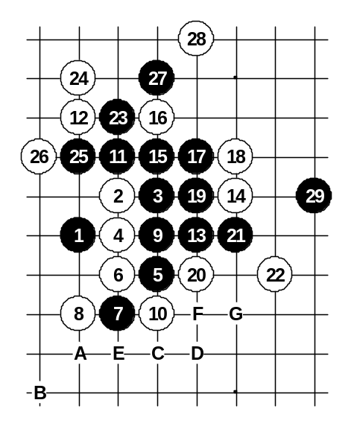

Diagram i2-81

Another 8th move. Moves sequence is really important at first. Move 9-9 is a good timing.
If 10-11, 12-10 then 13-16, 15-17.
If 10-11, 12-15 then 13-A, 14-B, 15-C, 17-D, 18-E, 19-20, 20-F, 21-G.

Diagram i2-82
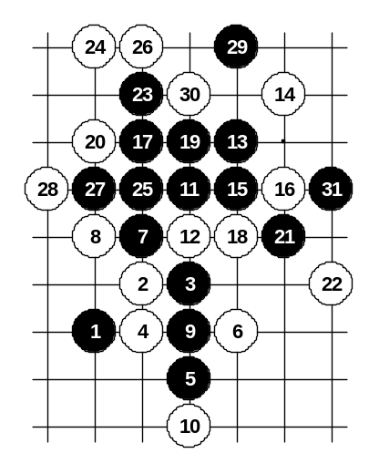

Another 6th move. Similar position can also come from i3 opening. In i3 opening, black wins easily in similar pattern, but here the win is quite difficult because of smaller space. On the diagram the first choice of the 16th move is shown.
If 18-27 then 19-19.
If 18-19 then 19-27.

